Web application requirements

Different screens of the application:

* Homepage
* Log In
* About
* Requirements
* Contact
* While logged in:
  + Donor:
    - Account
    - Edit account information
    - Apply for donation / Complete donation form
    - Check donation status
  + Staff:
    - Donor management
    - Other management pages
  + Doctor:
    - Request blood
    - Verify donors

Data storage:

Local database for testing and developing – MySQL, PostgreSQL, SSMS.

Online database after development – TBD.

User table containing UserID, Username, Password, TBA…

Donation table containing open donations with their ID, Blood type, amount needed, TBA…

Server-side data manipulation:

Possible server-database communication languages:

* Ruby
* Python
* PHP
* Java
* Javascript (node.js)

User action classes:

* Create, delete an account
* Update an account email adress, password
* Retrieve forgotten password
* Eventual support methods for sending a verification email, sending messages between users, contacting administrators, ETC…

Donation action classes:

* Create, verify, complete a donation
* Register different users to a single donation
* Allow doctors and staff to operate donation-related actions

Front-end design and style:

HTML, CSS and Javascript for developing and designing a user-friendly interface containing all application features.

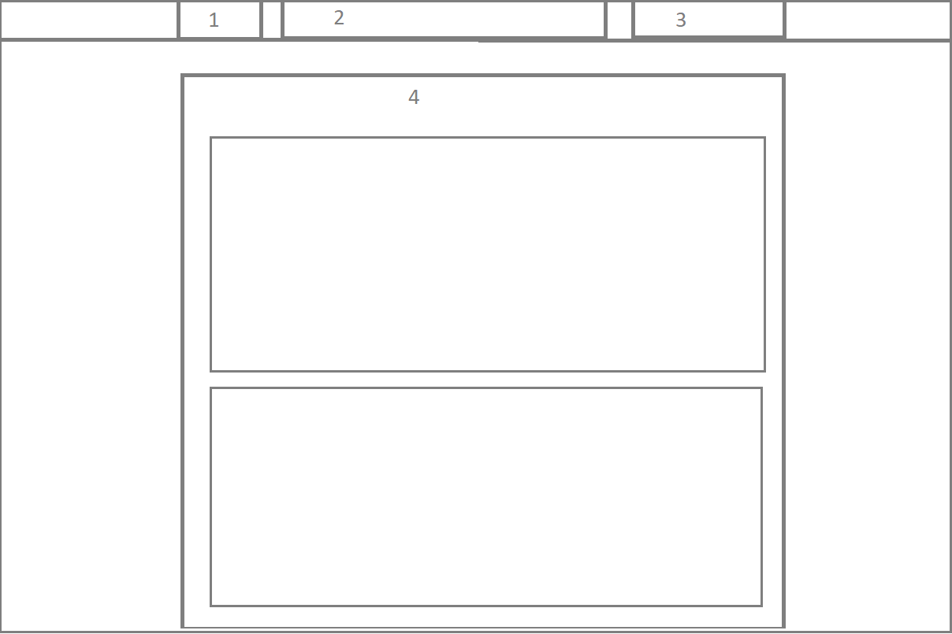Early design concept:

1. Logo/Hyperlink
2. Navigation bar
3. Login/Registration
4. Table of content

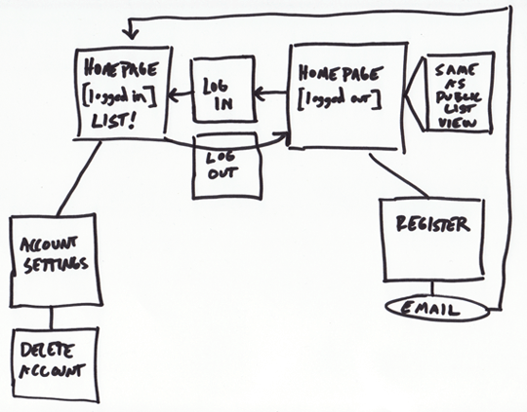Back-end workflow pattern: